DAY 3 ASSIGNMENT|LINUX ADMINISTRATION

1.Create a blank file named "myfile".

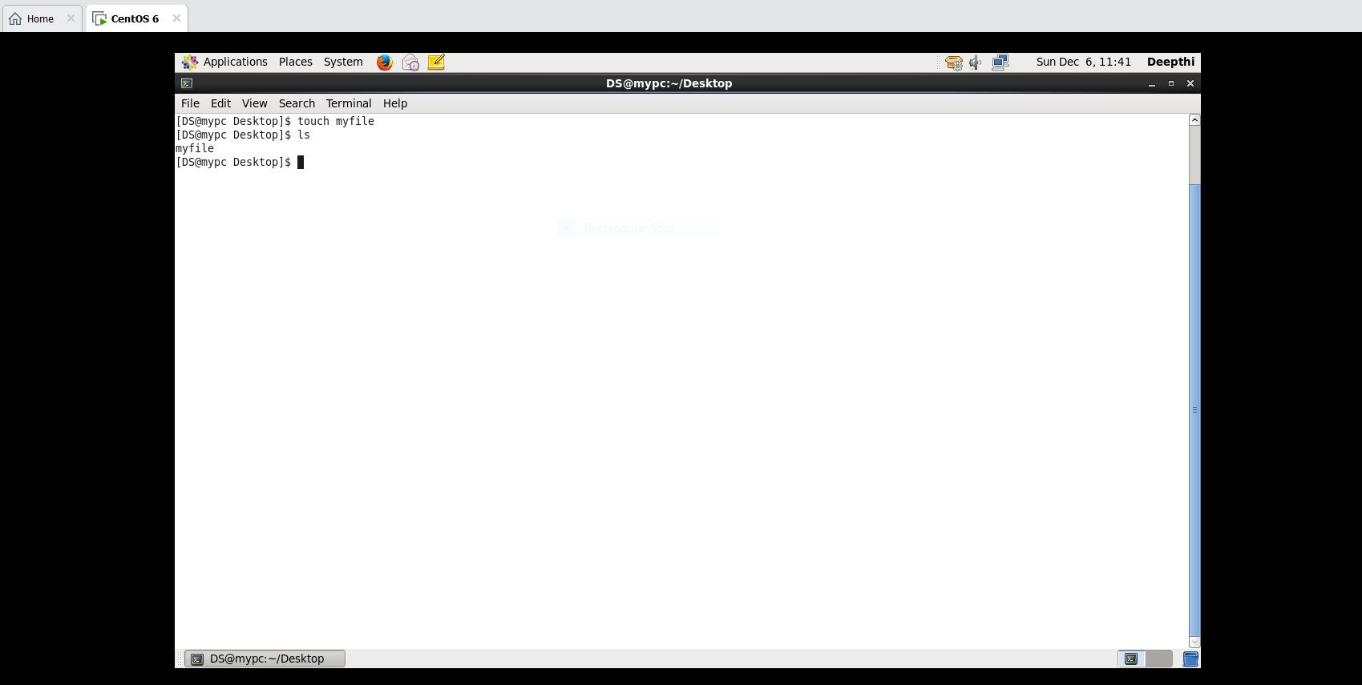

2.Open "myfile" in vi editor.

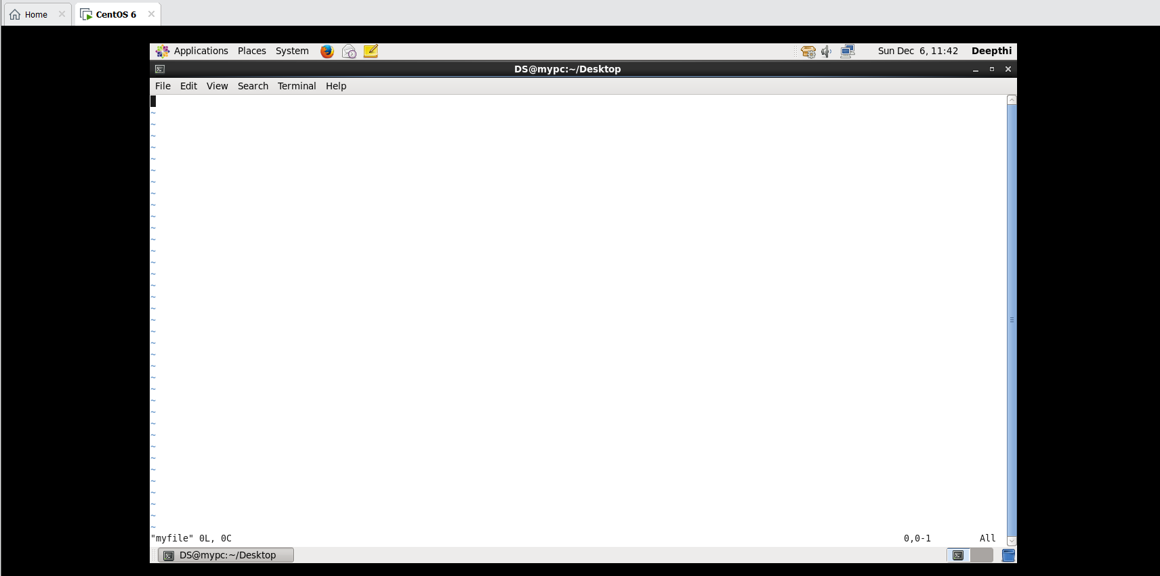

3. Write your name, address, email id, phone number and blood group in 5 different lines.

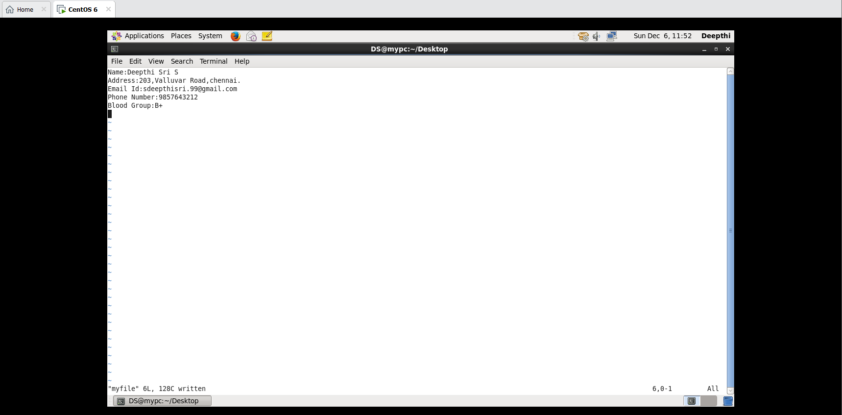

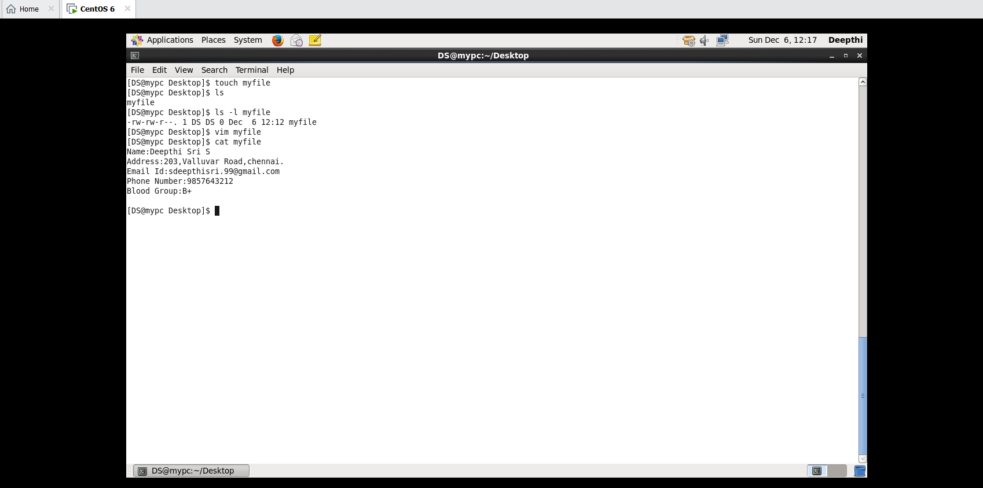

4. Build one single expression to see the line with your name and blood group in myfile.

